Creating a VPC with public, private subnets with route table

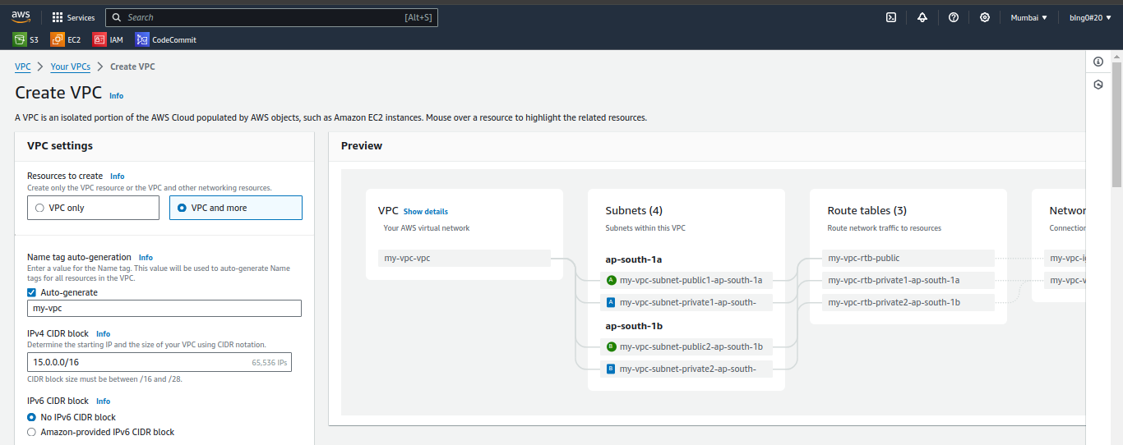

Availability zone and Number of private and public subnets:

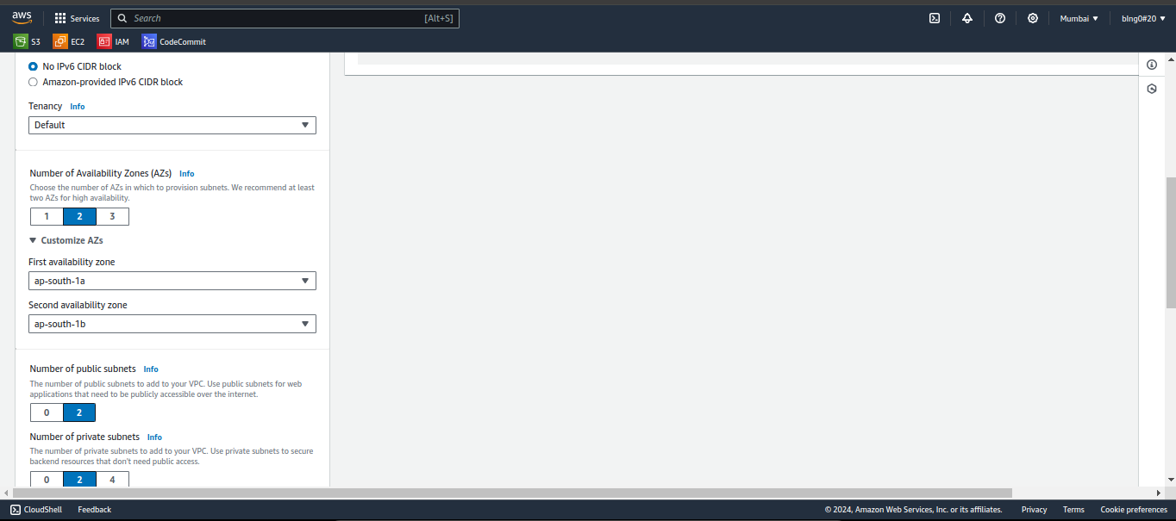

CIDR blocks for both public and private subnets:

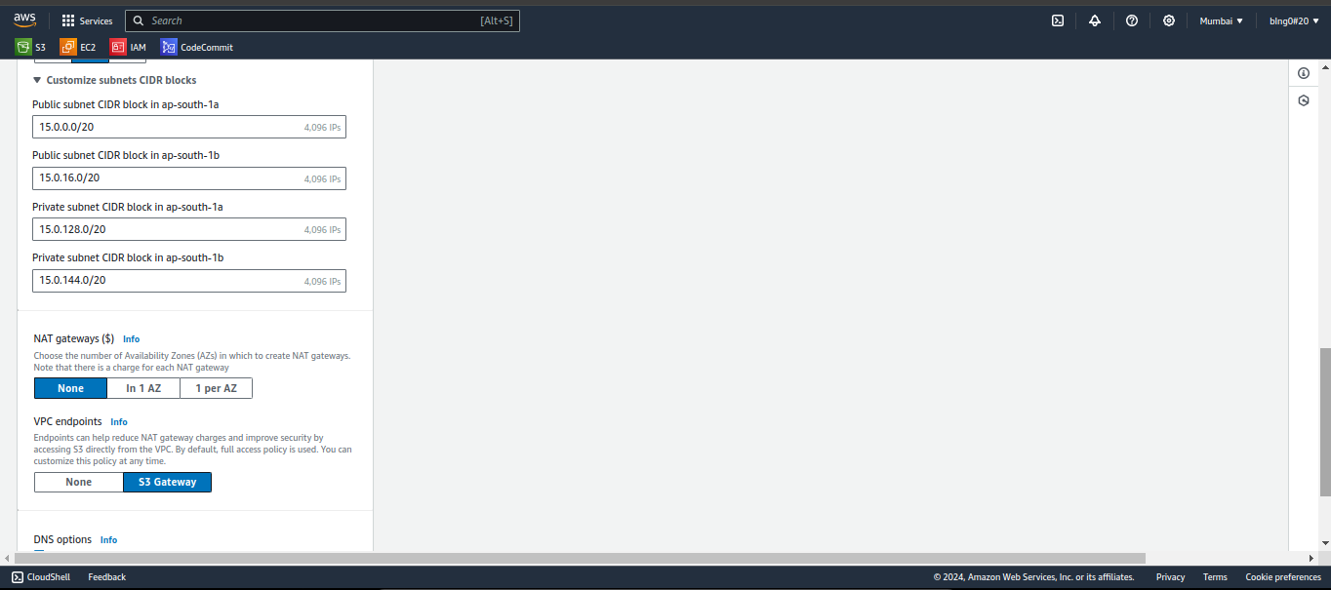

NAT gaeways and VPC endpoints are set to default values:

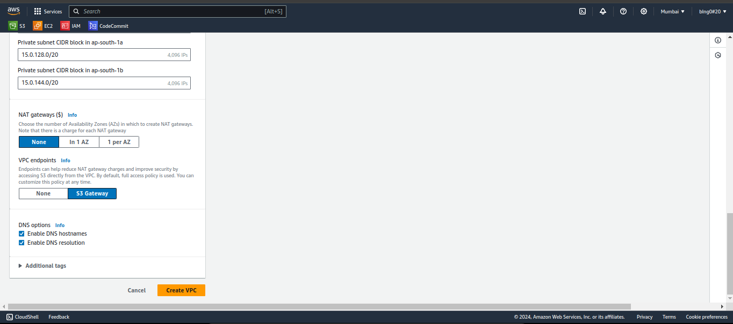

VPC Created:

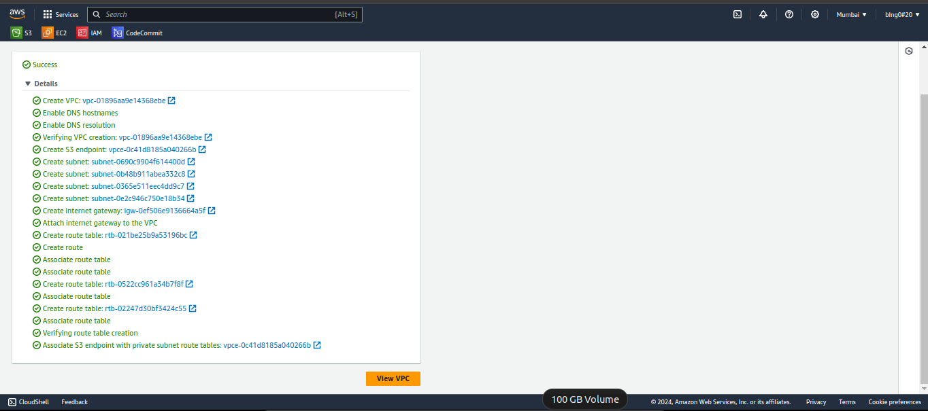

VPC:

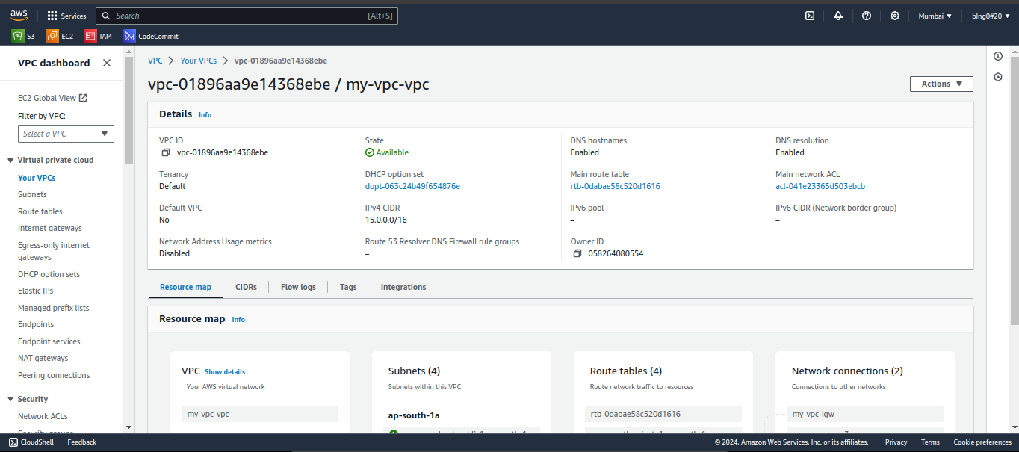

Subnets:

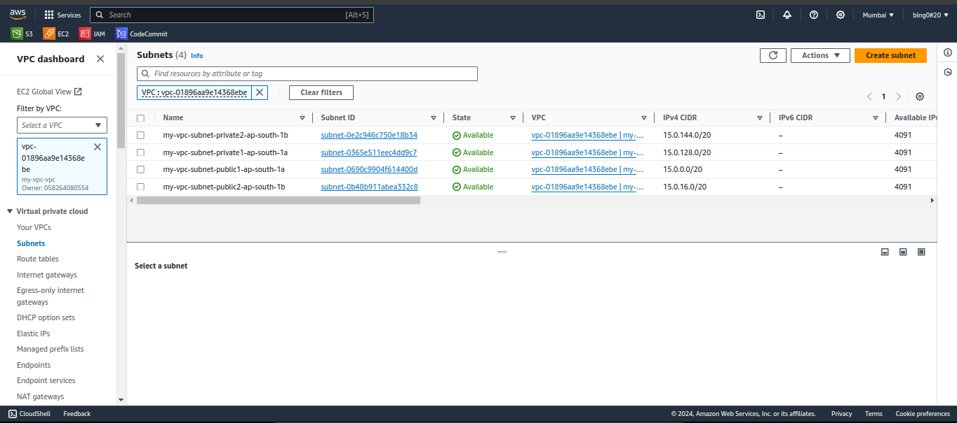

Route table:

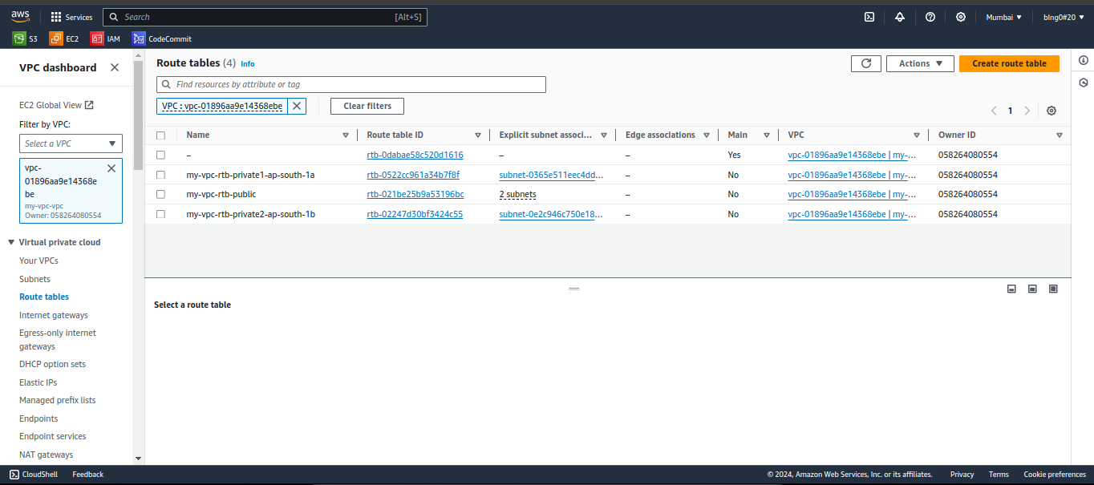

Internet gateways:

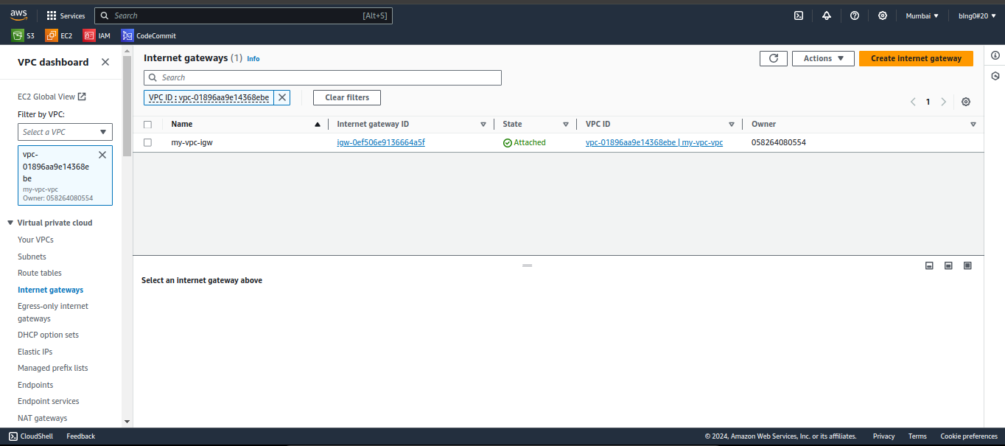

Creating and launching a Linux EC2 instance by using the above vpc and public subnet.

Name: Linux-server

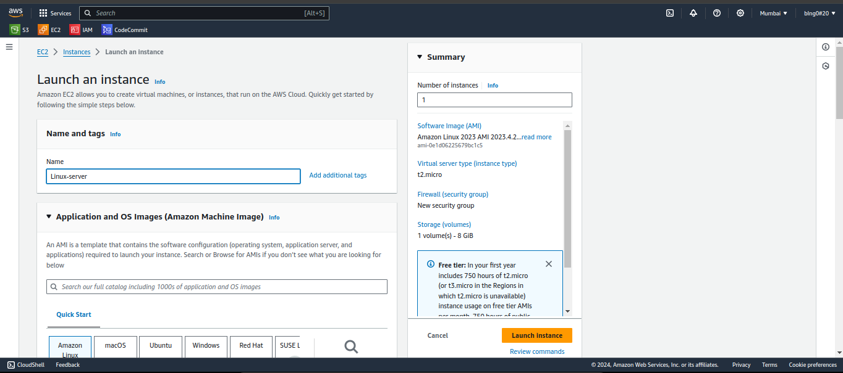

Selecting OS image as Amazon Linux:

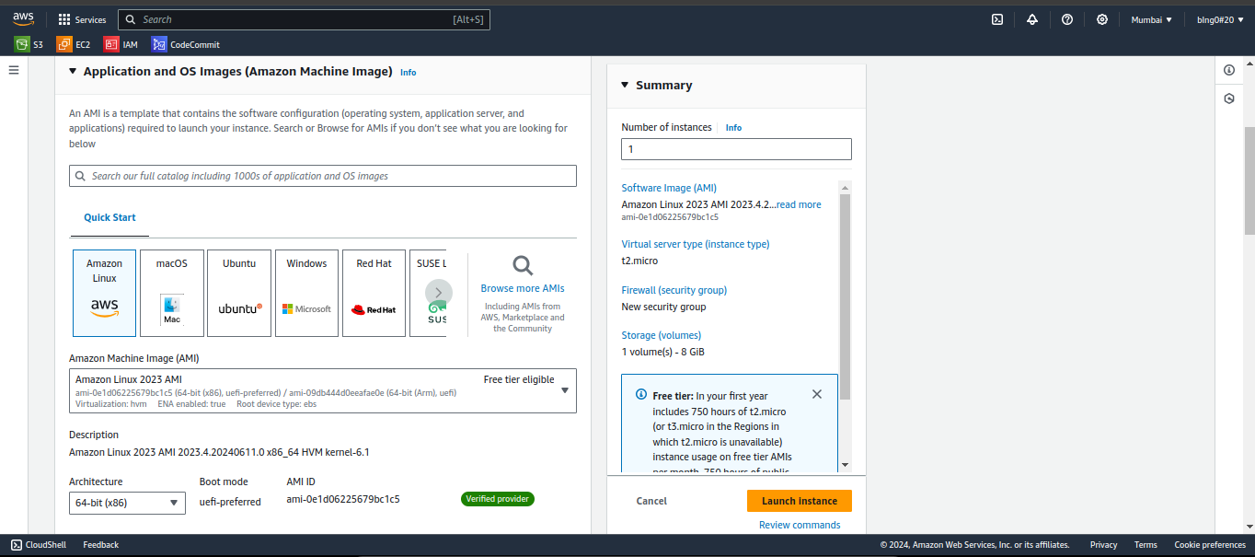

Instance type as t2.micro and created a key pair:

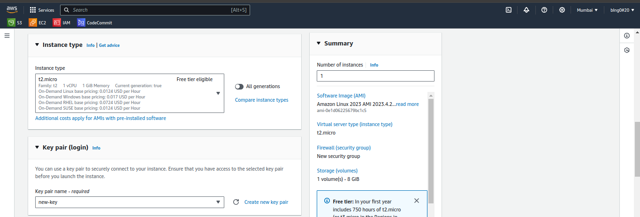

Selecting my vpc:

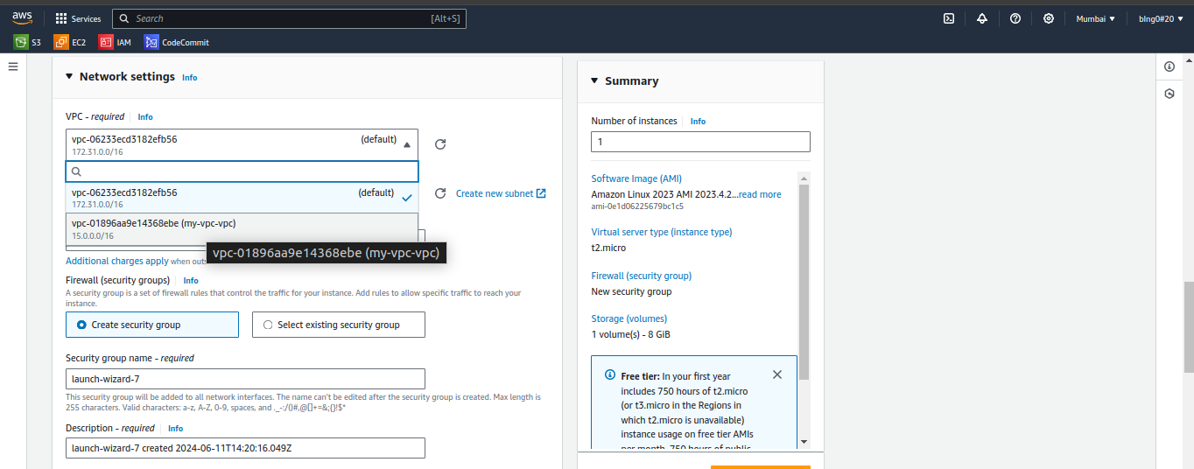

Selected my-vpc and public subnet:

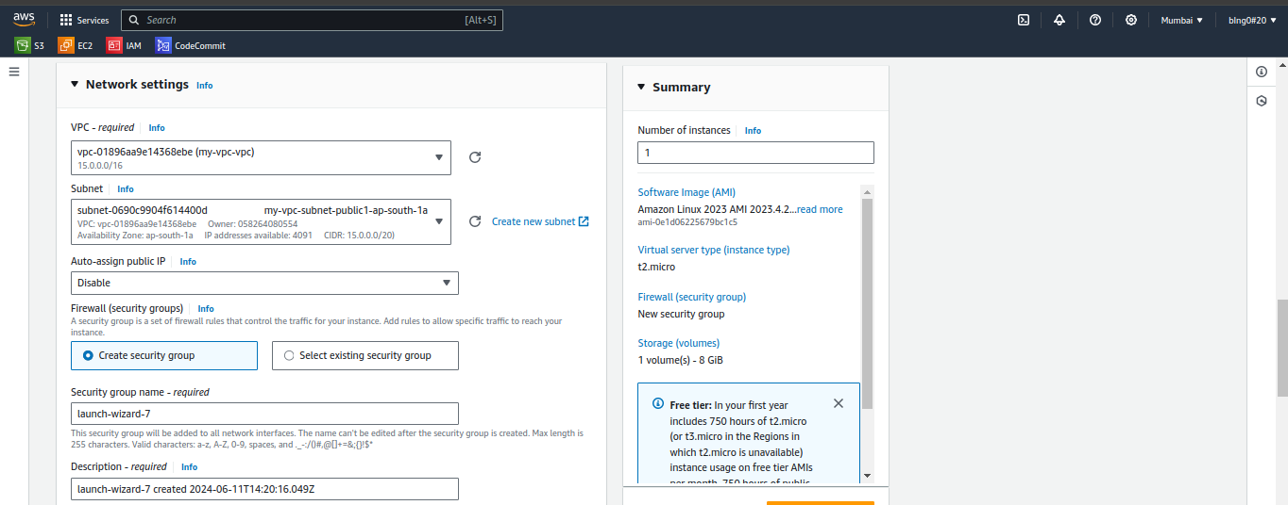

Launching instance (in progress):

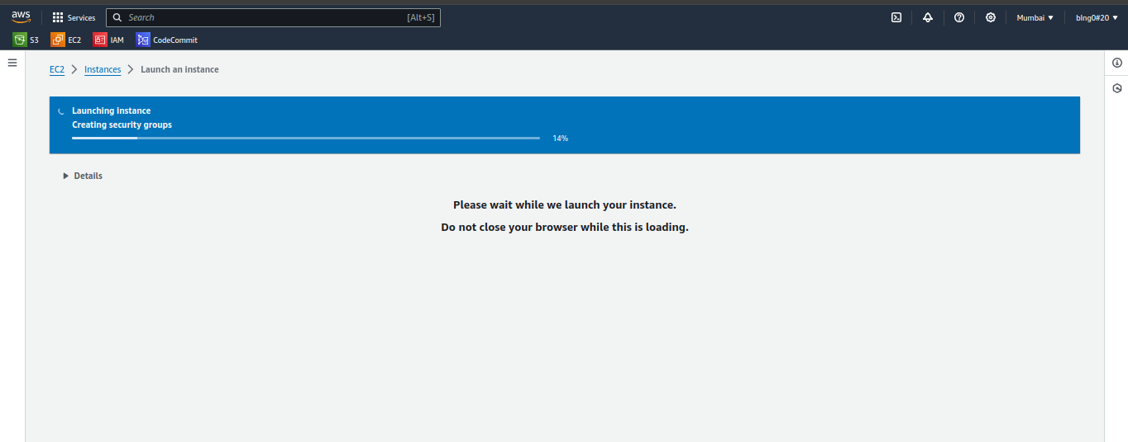

Linux instance has been created and running:

(showing the VPC id and subnet id)

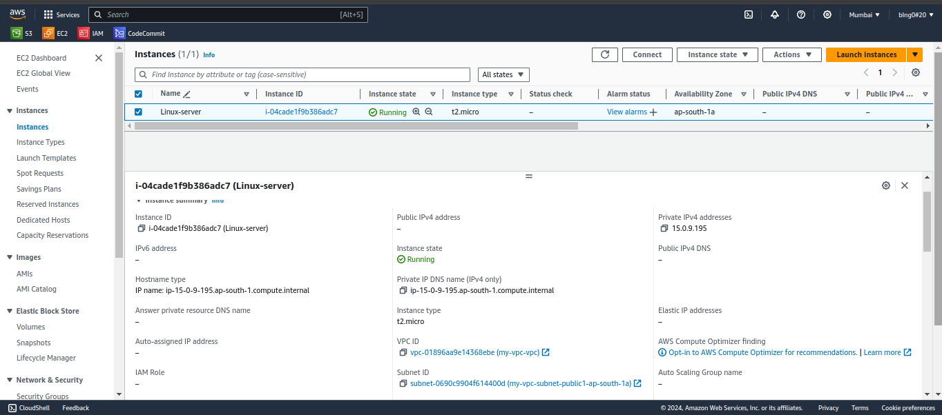

Connect to instance (setting up using connect endpoint):

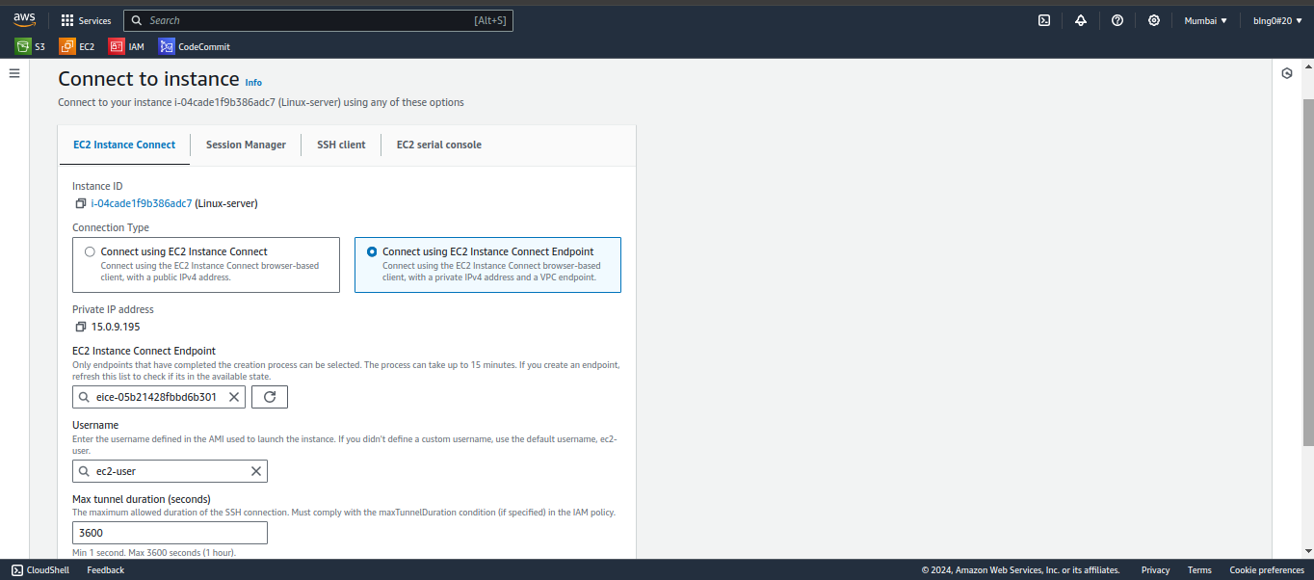

Connected to the Linux instance:

